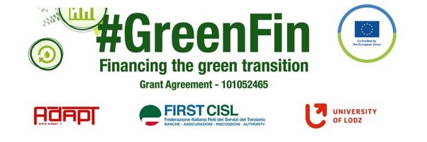

GOOD PRACTICE’S SUMMARY FORM*

*ONE FOR EACH COLLECTED DOCUMENT

DOCUMENT’S TITLE: Code of conduct on good outplacement in finance
COUNTRY: Denmark COMPANY: FSU Denmark SECTOR: Finance (Bank and insurance)
DOCUMENT’S DATE: 2020

TYPE OF DOCUMENT:
1. National law
2. Unilateral company or association system
3. European Federation agreement or statement
4. EWC agreement or statement
5. Sector collective agreement
6. Company collective agreement
7. Social dialogue good practice
8. Other (please specify)

CONTENT (KEY ELEMENTS)
Traning/retraining
- Continuing education on ‘Sustainable Customer Dialogue
- A four-day education developed in collaboration with “Finanssektorens Uddannelsescenter” aimed at business advisors. The course will train the Business Advisors in advising business customers on sustainability.
- The project started in 2021 as a pilot project where Finansforbundet and Finanssektorens Arbejdsgiverforening (the Danish Employers' Association for the Financial Sector) allocated 1 mio. DKK for training for a total of 100 business advisors in relation to advising companies on sustainable transformation. The funding was allocated through Finanskompetencepuljen (Finance Competence Fund). In 2022 an additional funding of 4 mio. DKK was allocated in order to train further 500 business advisors in 2022 and 2023.

- Courses on sustainable finance in Finanskompetencepuljen (Finance Competence Fund)
  - Finanskompetencepuljen is established via the collective agreement. As an employee in the financial sector, you can apply for support for continuing education if you want to develop your competencies. It is possible to apply for up to 3 courses per year. There are over 250 different courses in Finanskompetencepuljen, of which over 70 of the courses are in English.
In Finanskompetencepuljen there are also courses within sustainability and the strategy is to increase the number of courses within the field. Existing courses in Finanskompetencepuljen includes:
      - IT and sustainability
      - Management of Sustainable Development

COMMENTS/FURTHER DETAILS/IMPACT RELATED TO THE ABOVE DESCRIBED DOCUMENTS
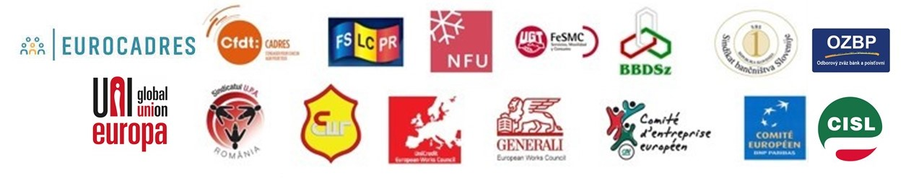
Links: Rules Concerning Termination of Employment (finansforbundet.dk)
A work life in motion (finansforbundet.dk)

