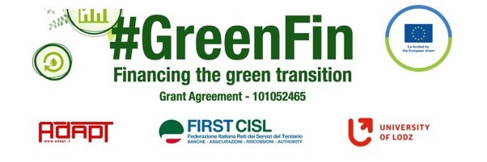

GOOD PRACTICE’S SUMMARY FORM*

*ONE FOR EACH COLLECTED DOCUMENT

DOCUMENT’S TITLE: Denmark’s recovery and resilience plan + Klimaloven (The climate law)
COUNTRY: Denmark COMPANY: FSU Denmark SECTOR: Finance (Bank and insurance)
DOCUMENT’S DATE: 2021

TYPE OF DOCUMENT:
1. National law
2. Unilateral company or association system
3. European Federation agreement or statement
4. EWC agreement or statement
5. Sector collective agreement
6. Company collective agreement
7. Social dialogue good practice
8. Other (please specify)

CONTENT (KEY ELEMENTS)
- The purpose of this Act is for Denmark to reduce greenhouse gas emissions in 2030 by 70 per cent compared to 1990 levels, and for Denmark to achieve a climate-neutral society by 2050 at the latest, with the Paris Agreement's goal of limiting the global temperature increase to 1.5 degrees Celsius in mind.
- The purpose of this Act is also for Denmark to reduce greenhouse gas emissions in 2025 by 50-54 per cent compared to 1990 levels.
Climate action shall take into account a number of guiding principles:
1) Climate challenges are a global issue. Therefore, Denmark must be a pioneer in international climate action that can inspire and influence the rest of the world. In addition, Denmark has both a historical and moral responsibility to take the lead.
2) The achievement of Denmark's climate goals must be as cost-effective as possible, taking into account both the long-term green transition, sustainable business development and Danish competitiveness, healthy public finances and employment, and that Danish business must be developed and not phased out.
3) Denmark must show that a green transition can be made and at the same time maintain a strong welfare society where cohesion and social balance are ensured.
4) The measures to be used to reduce greenhouse gas emissions must lead to real domestic reductions, but at the same time it must be ensured that Danish measures do not simply move all greenhouse gas emissions outside Denmark's borders.
- At least every five years, the Minister for Climate, Energy and Utilities sets a national climate target with a 10-year perspective. A new climate target must not be less ambitious than the most recently set target.
- The Minister for Climate, Energy and Utilities shall publish, at least every five years and at least in connection with the setting of the climate objectives referred to in paragraph 1, a climate action plan with a 10-year perspective.

COMMENTS/FURTHER DETAILS/IMPACT RELATED TO THE ABOVE DESCRIBED DOCUMENTS
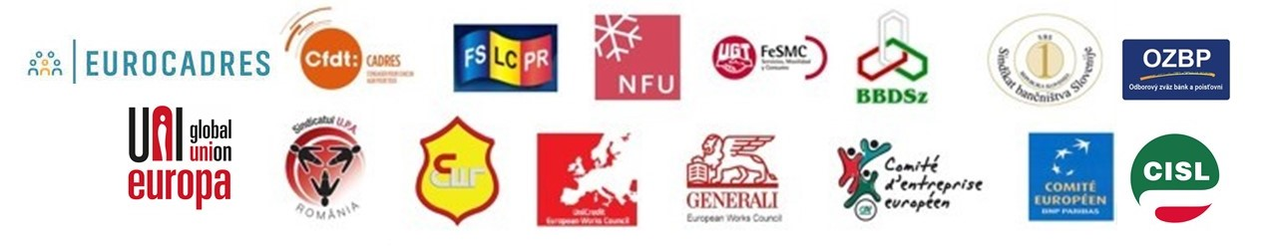
Links to documents: Denmark's Recovery and Resilience plan (fm.dk)
Klimaloven (retsinformation.dk)

