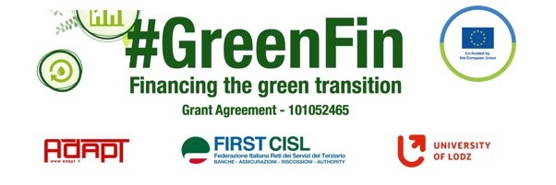

GOOD PRACTICE’S SUMMARY FORM*

*ONE FOR EACH COLLECTED DOCUMENT

DOCUMENT’S TITLE: Employees Climate panel – 8 demands on green transition
COUNTRY: Denmark COMPANY: FH (central organization where Forsikringsforbundet and FSU are part of) SECTOR: Cross-sectoral
DOCUMENT’S DATE: 2022

TYPE OF DOCUMENT:
1. National law
2. Unilateral company or association system
3. European Federation agreement or statement
4. EWC agreement or statement
5. Sector collective agreement
6. Company collective agreement
7. Social dialogue good practice
8. Other (please specify)

CONTENT (KEY ELEMENTS)
- How to engage workers in the green transition in 8 demands
- Build knowledge, make priorities, strengthen incentives for innovation, increase safety, think green and sustainable, appoint sustainability representatives, establish network for sustainability, share best practices

COMMENTS/FURTHER DETAILS/IMPACT RELATED TO THE ABOVE DESCRIBED DOCUMENTS
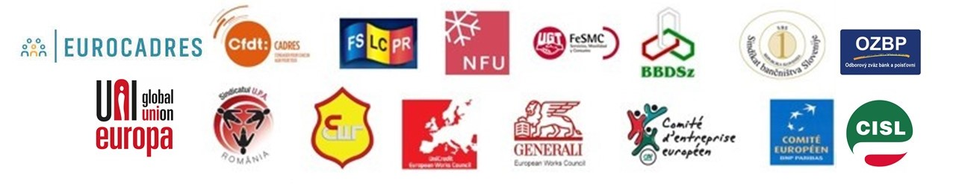
Full document is attached

