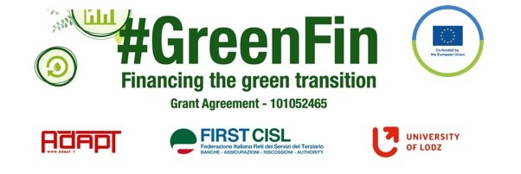

GOOD PRACTICE’S SUMMARY FORM*

*ONE FOR EACH COLLECTED DOCUMENT

DOCUMENT’S TITLE: Framework agreement on remote work
COUNTRY: Denmark COMPANY: FSU Denmark SECTOR: Finance (bank and insurance)
DOCUMENT’S DATE: June 2021

TYPE OF DOCUMENT:
1. National law
2. Unilateral company or association system
3. European Federation agreement or statement
4. EWC agreement or statement
5. Sector collective agreement
6. Company collective agreement
7. Social dialogue good practice
8. Other (please specify)

CONTENT (KEY ELEMENTS)
- Considering the experiences of working from home during the pandemic Finansforbundet and FA agreed to suspend some requirements in the framework agreement on remote work in order to allow employees and the companies more flexibility in organising remote working. The requirements are suspended until 31 March 2023.

COMMENTS/FURTHER DETAILS/IMPACT RELATED TO THE ABOVE DESCRIBED DOCUMENTS
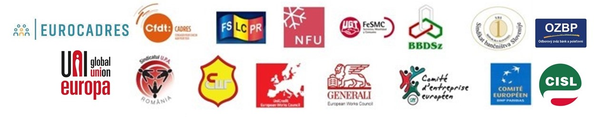
Link to document: The flexible work life (finansforbundet.dk)

