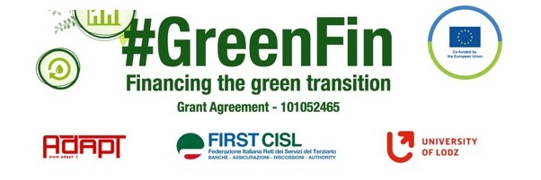

GOOD PRACTICE’S SUMMARY FORM
DOCUMENT’S TITLE: Accord relative à l’accompagnement de la mobilité durable
Company collective agreement on an experimentation on sustainable mobility

COUNTRY: France COMPANY: Allianz SECTOR: (1. Finance) DOCUMENT’S DATE: 26 January 2022

TYPE OF DOCUMENT:
6. Company collective agreement

CONTENT (KEY ELEMENTS)
- -according to the law of 24 December 2019 on the orientation of mobilities to more sustainable formats, the agreement is orientating workplace-home movements to more sustainable ways of transport than an individual car.
- Vehicles concerned: bicycles with or without motor, car-sharing, scooters and electrical trottinettes
- Financing of a € 400 allocation and possibility to cumulate with common transport forfaits (up to €500)
- A promotional offer subscribe to an insurance for the cycle
- Possibility to use a secure parking space at the company’s premices

RELATED TEXTS/DOCUMENTS/AGREEMENTS (If the document/agreement described above is resulting from a national law or a European Directive, a previous agreement, the Collective national agreement, etc. please specify, add a small description and, if possible, add the file or the link to the document.). YOU DO NOT NEED TO TRANSLATE INTO ENGLISH THE RELATED DOCUMENT.
The document refers to a National law: N° 2019-1428 of December 24, 2019 which gives priority to collective bargaining to put into place collective agreements on a more sustainable mobility. They have been applied to all sectors. If no agreement could be reached, a notice of disagreement is issued. If no company agreement has been reached, an agreement on the level of the branch can be used.
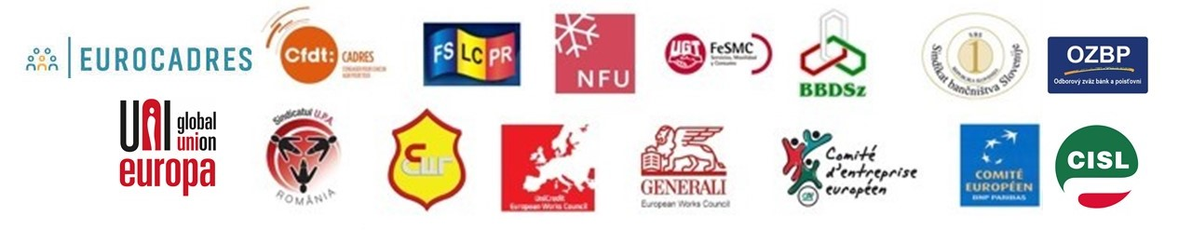
For negotiations, data from a specific social database (BDESE) can be used, especially concerning the measure of greenhouse gaz emissions due under the NFRD (and later the CSRD)

