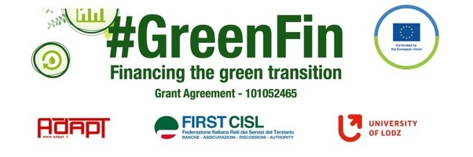

SWOT ANALYSIS

Evaluate critically the laws, collective agreements and good practices you have collected. Highlight the innovative and positive aspects (strengths) and the opportunities, but also the weaknesses and threats of each document using the SWOT analysis methodology.
Thank you!

NAME …Simon Jernberg………….
ORGANIZATION/TRADE UNION …Nordic financial unions……
COMPANY …Nordic examples…………
COUNTRY…Nordics…….
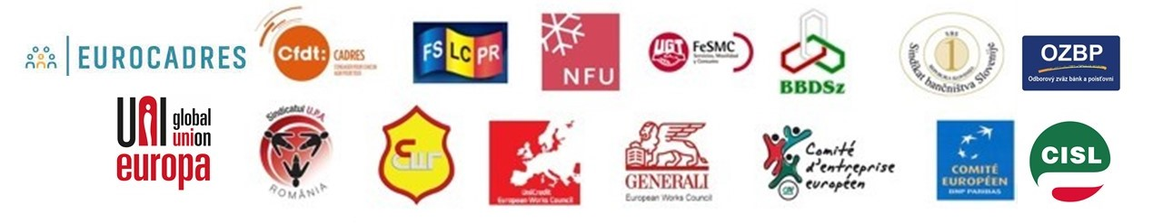

SWOT ANALYSIS – FSU Sweden Position paper Sustainable Finance
TYPE OF DOCUMENT (collective agreement/law/good practice) …Position paper…………….
COMPANY/COUNTRY …FSU Sweden……………………. DATE…2022………………

Point out and summarize the document’s strengths (positive and innovative aspects - steps forward with respect to the previous situation) and weaknesses (negative aspects and improvement areas), the opportunities (the possible positive future developments) and threats (external/internal factors that could put in danger the situation in the future).

Strengths
Weaknesses

- Strong position that includes not only environmental but also social sustainability...
- Clear goals intrenally and externally...
- …………………………
- …………………………
- …………………………
- …………………………

- This is a position – how will it be taken into action?…
- …………………………
- …………………………
- …………………………
- …………………………
- …………………………

Opportunities
Threats

- Is there an interest from Banks to work on social sustainability?...
- …………………………
- …………………………
- …………………………
- …………………………
- …………………………

- Cooperation with the banks and financial actors…
- …………………………
- …………………………
- …………………………
- …………………………
- …………………………

SWOT ANALYSIS – Collective agreement BAO and FSU Sweden

TYPE OF DOCUMENT (collective agreement/law/good practice) …Collective agreement…
COMPANY/COUNTRY …FSU Sweden……………………………. DATE…2015-………………

Point out and summarize the document’s strengths (positive and innovative aspects - steps forward with respect to the past situation) and weaknesses (negative aspects and improvement areas), the opportunities (the possible positive future developments) and threats (external/internal factors that could put in danger the situation in the future).

Strengths
Weaknesses

- A strong agreement that covers a wide range of rights………
- Sector wide agreement………
- …………………………
- …………………………
- …………………………
- …………………………

- …The agreement has no end date – when and what can be added?……
- …………………………
- …………………………
- …………………………
- …………………………
- …………………………

Opportunities
Threats

- The agreement has indicated numbers for lowest salaries …………………………
- …………………………
- …………………………
- …………………………
- …………………………
- …………………………

- The agreement has no end date – low risk of being overhauled……
- …………………………
- …………………………
- …………………………
- …………………………
- …………………………

SWOT ANALYSIS – Employees climate panel – 8 demands on green transition

TYPE OF DOCUMENT (collective agreement/law/good practice) …Good practice…….
COMPANY/COUNTRY …Forsikringsforbundet Denmark……………. DATE…2022………

Point out and summarize the document’s strengths (positive and innovative aspects - steps forward with respect to the past situation) and weaknesses (negative aspects and improvement areas), the opportunities (the possible positive future developments) and threats (external/internal factors that could put in danger the situation in the future).

Strengths
Weaknesses

- The common view that this is important and that a wide range of trade unions stand behind the demands…
- …………………………
- …………………………
- …………………………
- …………………………
- …………………………

- Clear demands but the challenge lay in how to do it…
- …………………………
- …………………………
- …………………………
- …………………………
- …………………………

Opportunities
Threats

- …………………………
- …………………………
- …………………………
- …………………………
- …………………………
- …………………………

- The wide network and clear demands will give strength in how to follow up…
- …………………………
- …………………………
- …………………………
- …………………………
- …………………………

SWOT ANALYSIS – Denmark’s recovery and resilience plan

TYPE OF DOCUMENT (collective agreement/law/good practice) …Law…….
COMPANY/COUNTRY …Denmark……………………………. DATE…2022………………

Point out and summarize the document’s strengths (positive and innovative aspects - steps forward with respect to the past situation) and weaknesses (negative aspects and improvement areas), the opportunities (the possible positive future developments) and threats (external/internal factors that could put in danger the situation in the future).

Strengths
Weaknesses

- That it is a law and national plan make it strong …………………………
- …………………………
- …………………………
- …………………………
- …………………………
- …………………………

- …………………………
- …………………………
- …………………………
- …………………………
- …………………………
- …………………………

Opportunities
Threats

- Implementation and follow up...
- …………………………
- …………………………
- …………………………
- …………………………
- …………………………

- Nation wide initiative, part of national legislation and hence national budget…
- …………………………
- …………………………
- …………………………
- …………………………
- …………………………

