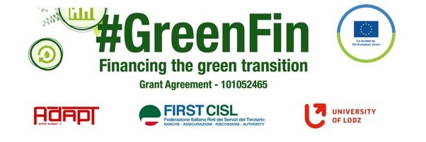

GOOD PRACTICE’S SUMMARY FORM*

*ONE FOR EACH COLLECTED DOCUMENT

DOCUMENT’S TITLE: Collective agreement BAO and Finansförbundet
COUNTRY: Sweden COMPANY: FSU Sweden SECTOR: Bank
DOCUMENT’S DATE: 2015-

TYPE OF DOCUMENT:
1. National law
2. Unilateral company or association system
3. European Federation agreement or statement
4. EWC agreement or statement
5. Sector collective agreement
6. Company collective agreement
7. Social dialogue good practice
8. Other (please specify)

CONTENT (KEY ELEMENTS)
- The agreement is between the employers organization and trade union
- The agreement regulates and guarantees: working hours, Salary, Per diem, Holiday, Sick leave, Parental leave, Termination and Telework
COMMENTS/FURTHER DETAILS/IMPACT RELATED TO THE ABOVE DESCRIBED DOCUMENTS
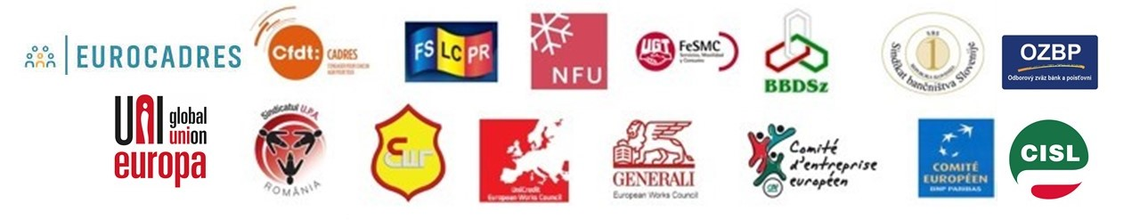
The agreement is attached

