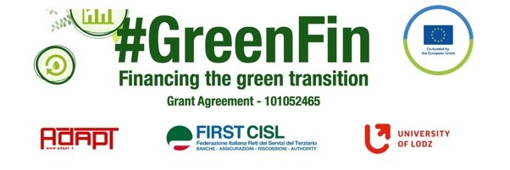

GOOD PRACTICE’S SUMMARY FORM*

*ONE FOR EACH COLLECTED DOCUMENT

DOCUMENT’S TITLE: Finansförbundets position i Hållbar finans / FSU Sweden’s position on Sustainable Finance
COUNTRY: Sweden COMPANY: FSU Sweden SECTOR: Bank
DOCUMENT’S DATE: 2022

TYPE OF DOCUMENT:
1. National law
2. Unilateral company or association system
3. European Federation agreement or statement
4. EWC agreement or statement
5. Sector collective agreement
6. Company collective agreement
7. Social dialogue good practice
8. Other (please specify) – Position paper

CONTENT (KEY ELEMENTS)
- The aim of the paper is to present the position of FSU Sweden on Sustainable finance
- Banks have an important role to play in the transition which puts demand on them to also consider social aspects of the sustainable transition.
- FSU Sweden has two roles to play:
- Internally at the banks to work on social responsibility and social sustainability, where workers rights and conditions are in focus.
- Externally on social responsibility and sustainable investments where banks have the responsibility to contribute to a sustainable economy that take into account environment and humans

COMMENTS/FURTHER DETAILS/IMPACT RELATED TO THE ABOVE DESCRIBED DOCUMENTS
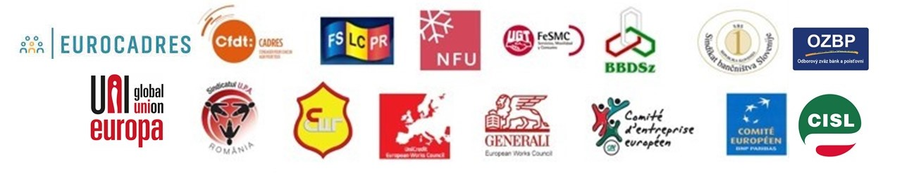
The paper is attached

