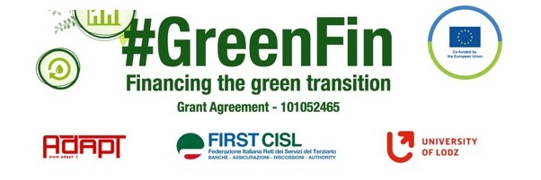

GOOD PRACTICE’S SUMMARY FORM*

*ONE FOR EACH COLLECTED DOCUMENT

DOCUMENT’S TITLE: Sector collective agreement 19-12-2019
COUNTRY: Italy COMPANY: SECTOR: Bank
DOCUMENT’S DATE:

TYPE OF DOCUMENT:
1. National law
2. Unilateral company or association system
3. European Federation agreement or statement
4. EWC agreement or statement
5. Sector collective agreement
6. Company collective agreement
7. Social dialogue good practice
8. Other (please specify)

CONTENT (KEY ELEMENTS)
- Provisions to regulate the modalities of remote working and the right to disconnect
- With the purpose to incentivize work-life balance
- To determine a positive impact on environment and workers’ mobility
- Maximum limit of 10 remote working days per month
- Clear reference to the official working time to determine the concrete right of disconnection

COMMENTS/FURTHER DETAILS/IMPACT RELATED TO THE ABOVE DESCRIBED DOCUMENTS




