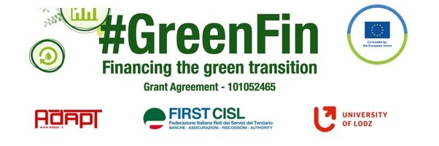

GOOD PRACTICE’S SUMMARY FORM*

*ONE FOR EACH COLLECTED DOCUMENT

DOCUMENT’S TITLE: Generali company collective agreement on remote work
COUNTRY: Italy COMPANY: Generali SECTOR: Insurance
DOCUMENT’S DATE: 2021

TYPE OF DOCUMENT:
1. National law
2. Unilateral company or association system
3. European Federation agreement or statement
4. EWC agreement or statement
5. Sector collective agreement
6. Company collective agreement
7. Social dialogue good practice
8. Other (please specify)

CONTENT (KEY ELEMENTS)
- Key provisions to regulate the modalities of remote working
- Maximum flexibility, but no full remote work is possible
- 300 euro lump-sum reimbursement for home costs
- meal voucher on a daily base
- The right to disconnect is clearly referred to the official daily working hours

COMMENTS/FURTHER DETAILS/IMPACT RELATED TO THE ABOVE DESCRIBED DOCUMENTS




