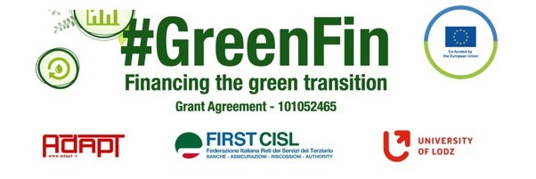

GOOD PRACTICE’S SUMMARY FORM*

*ONE FOR EACH COLLECTED DOCUMENT

DOCUMENT’S TITLE: Agreement on guidelines for sector remote work 26-02-2021
COUNTRY: Italy COMPANY: SECTOR: Insurance
DOCUMENT’S DATE:

TYPE OF DOCUMENT:
1. National law
2. Unilateral company or association system
3. European Federation agreement or statement
4. EWC agreement or statement
5. Sector collective agreement
6. Company collective agreement
7. Social dialogue good practice
8. Other (please specify)

CONTENT (KEY ELEMENTS)
- Provisions to regulate the modalities of remote working and the right to disconnect
- With the purpose to incentivize work-life balance
- To determine a positive impact on environment and workers’ mobility
- Full flexibility with reference to times and places
- No limits referred to remote working days

COMMENTS/FURTHER DETAILS/IMPACT RELATED TO THE ABOVE DESCRIBED DOCUMENTS
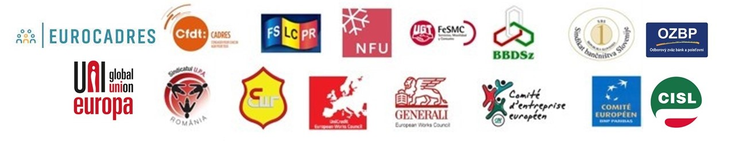
The guidelines have been included in the insurance sector collective agreement signed 15 november 2022

