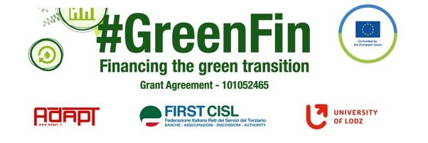

SWOT ANALYSIS

Evaluate critically the laws, collective agreements and good practices you have collected. Highlight the innovative and positive aspects (strengths) and the opportunities, but also the weaknesses and threats of each document using the SWOT analysis methodology.
Thank you!

NAME Jana Szaszova
ORGANIZATION/TRADE UNION OZBP
COMPANY UniCredit Bank
COUNTRY Slovakia
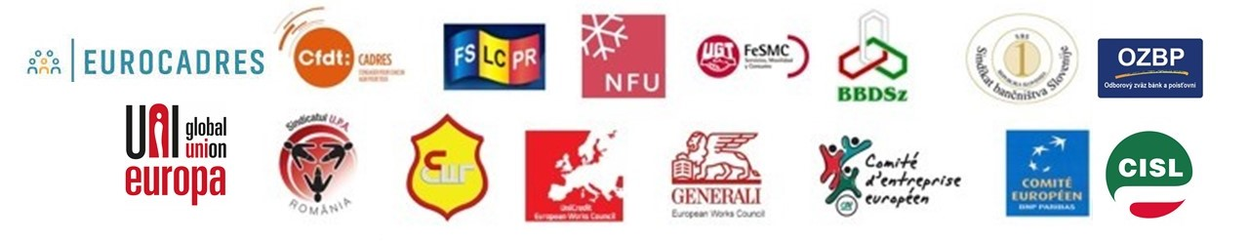
SWOT ANALYSIS – All documents connected to ESG
COMPANY/COUNTRY Slovakia DATE April 2023

Point out and summarize the document’s strengths (positive and innovative aspects - steps forward with respect to the previous situation) and weaknesses (negative aspects and improvement areas), the opportunities (the possible positive future developments) and threats (external/internal factors that could put in danger the situation in the future).

Strengths
Weaknesses

- Remuneration policy is a part of the CA, but it has
nothing common with the Regulation of EU, it is a
right based on National Labour Code

- …………………………
- …………………………
- …………………………
- …………………………

- It is difficult to
agree on transparent and
equal remuneration
- ESG is not discussed with TU at all
- ESG is focused mainly
on environment and products - investment and insurance

Opportunities
Threats

- ESG as is tackled by banks is a mere formality and helps banks present themselves in a positive light but reality is completely different

- In case TU is involved in the process, banking sector could me more sustainable and could help create better society

Good resource that shows how banks implement ESG are annual reports. Here are main points which are they focused on:
VUB (Intesa Group):
- to sustain commercial performance
- isuing of green bonds
- foundation suporting ecological projects
- financial and environmental education of children and youth

SLSP (Erste Group):
- isuing of green bonds
- financial and environmental education of children and youth

UniCredit Bank
- supporting ecological project
- charity
- supporting renewable resources of energy

ESG itself is very formal and only helps create positive picture of society and companies but, actualy it just makes life of European citizens more complicated and expensive. There is no doubt that we all should be responsible, protect nature and environment. But:
- European economy creates only small part of all worlds production. The main producers of pollution are bigger players in other continents, very often, but not only, in countries where lot of people suffer from poverty.
- Lot of multinationals produce their goods or part of them outside Europe, in poor countries, where nobody cares about environment and pollution. They do it because of cheep workforce. In addition, these goods are transported from one part of world to another through all planet via unecological means of transport.
These are to main fact that prove that ESG is just game. False game which does not solve problems.

