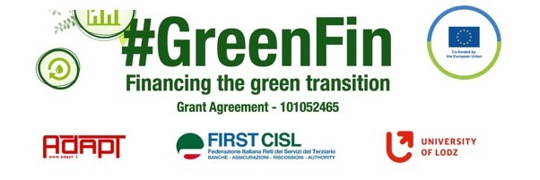

GOOD PRACTICE’S SUMMARY FORM*

*ONE FOR EACH COLLECTED DOCUMENT

DOCUMENT’S TITLE: Risk Inclusion Policy
COUNTRY: Slovakia COMPANY: UniCredit Bank SECTOR: Banking
DOCUMENT’S DATE: 5.11.2021

TYPE OF DOCUMENT:
1. National law
2. Unilateral company or association system
3. European Federation agreement or statement
4. EWC agreement or statement
5. Sector collective agreement
6. Company collective agreement
7. Social dialogue good practice
8. Other (please specify)

CONTENT (KEY ELEMENTS)
- Approval process of products in the Bank – mainly investment and insurance products
- General principles of access to the products - Sustainability factor must be taken into consideration as regards suppliers, partners, and products
- Counseling in investment and insurance
- Transparency of remuneration policies and sustainability in remuneration schemes

COMMENTS/FURTHER DETAILS/IMPACT RELATED TO THE ABOVE-DESCRIBED .DOCUMENTS
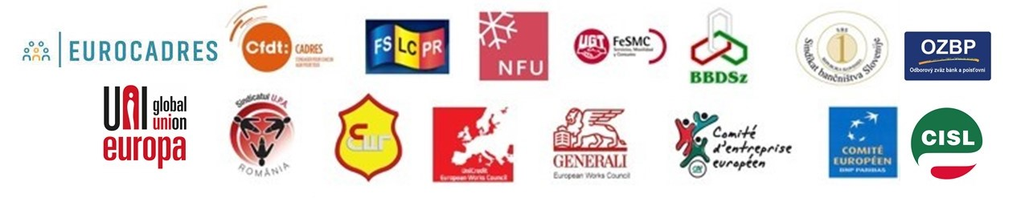
This document is mere formality. I will comment all document and approach of the banks in Slovakia to ESG separately.

