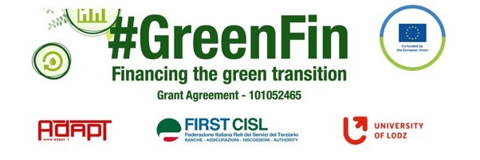

GOOD PRACTICE’S SUMMARY FORM*

*ONE FOR EACH COLLECTED DOCUMENT

DOCUMENT’S TITLE: Statement of adverse impacts on sustainability
COUNTRY: Slovakia COMPANY: UniCredit Bank SECTOR: Banking
DOCUMENT’S DATE: 10.3.2021

TYPE OF DOCUMENT:
1. National law
2. Unilateral company or association system
3. European Federation agreement or statement
4. EWC agreement or statement
5. Sector collective agreement
6. Company collective agreement
7. Social dialogue good practice
8. Other (please specify)

CONTENT (KEY ELEMENTS)
- Definition of terms of the Regulation EP and the Council (EU) 2019/2088 on the disclosure of information on sustainability in the financial services sector
- Statement that while providing investment and insurance products the factors of the sustainability are taken into account
COMMENTS/FURTHER DETAILS/IMPACT RELATED TO THE ABOVE-DESCRIBED DOCUMENTS
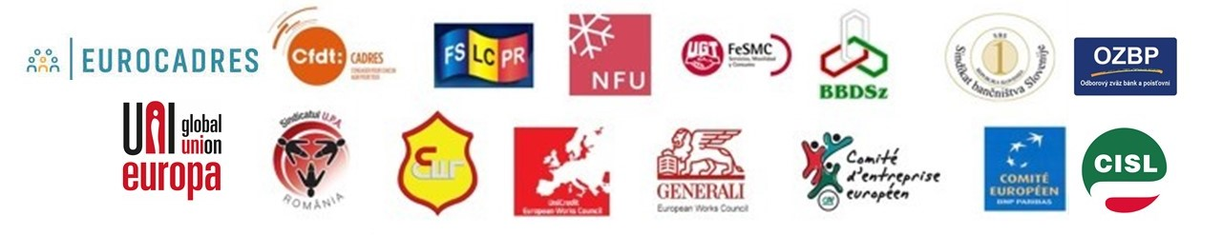
This document is mere formality. I will comment separately all document and approach of the banks in Slovakia to ESG.

