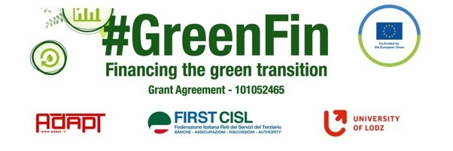

SWOT ANALYSIS

Evaluate critically the laws, collective agreements and good practices you have collected. Highlight the innovative and positive aspects (strengths) and the opportunities, but also the weaknesses and threats of each document using the SWOT analysis methodology.
Thank you!

NAME Luciano Malvolti
ORGANIZATION/TRADE UNION Uni Europa
COMPANY ……………
COUNTRY ………………….
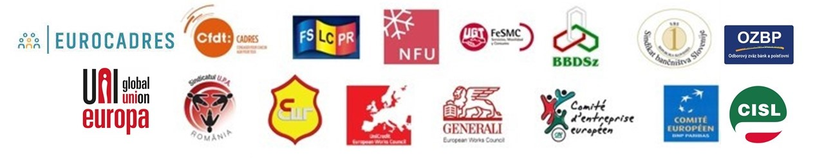

SWOT ANALYSIS – DOCUMENT N.1 (NAME/TITLE)
TYPE OF DOCUMENT (collective agreement/law/good practice) EU Finance Sector Social Dialogue Joint Declarations on Telework and Digitalization 2015-2021
COMPANY/COUNTRY …………………………………………………. DATE…………………

Point out and summarize the document’s strengths (positive and innovative aspects - steps forward with respect to the previous situation) and weaknesses (negative aspects and improvement areas), the opportunities (the possible positive future developments) and threats (external/internal factors that could put in danger the situation in the future).

Strengths
Weaknesses

- Shared principles and commitments agreed at European level by Trade Union Federations and Bank Associations
- On remote working modalities, training, social impact and so on
- ..

- Joint Declarations signed at transnational level have no binding value
- Further steps of negotiations at national or company level are necessary
- ..

Opportunities
Threats

- Collective Bargaining at sector level is under attack in many European countries
- ..

- Joint Declarations signed at transnational level can/should can push Social Dialogue at national and company level
- Expecially in countries where industrial relations are weaker
- ..

