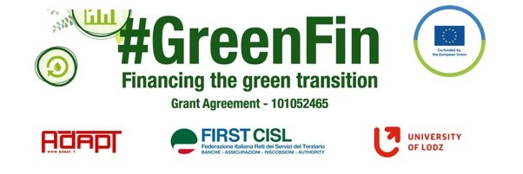

GOOD PRACTICE’S SUMMARY FORM*

*ONE FOR EACH COLLECTED DOCUMENT

DOCUMENT’S TITLE: Labor Law
COUNTRY: Montenegro COMPANY: SECTOR:
DOCUMENT’S DATE: 2022

TYPE OF DOCUMENT:
1. National law
2. Unilateral company or association system
3. European Federation agreement or statement
4. EWC agreement or statement
5. Sector collective agreement
6. Company collective agreement
7. Social dialogue good practice
8. Other (please specify)

CONTENT (KEY ELEMENTS)
- Employment contract for the performance of work outside the employer's premises
- Records of employment contracts for the performance of work outside the employer's premises
- Reimbursement of other costs related to the performance of work and the method of their determination
- The labor inspection can prohibit the employer from performing work outside the employer's premises when there is an immediate danger to the life and health of the employees and if this work endangers the environment
- Professional training and development defined
- Professional training is performed, as a rule, during working hours
COMMENTS/FURTHER DETAILS/IMPACT RELATED TO THE ABOVE DESCRIBED DOCUMENTS




