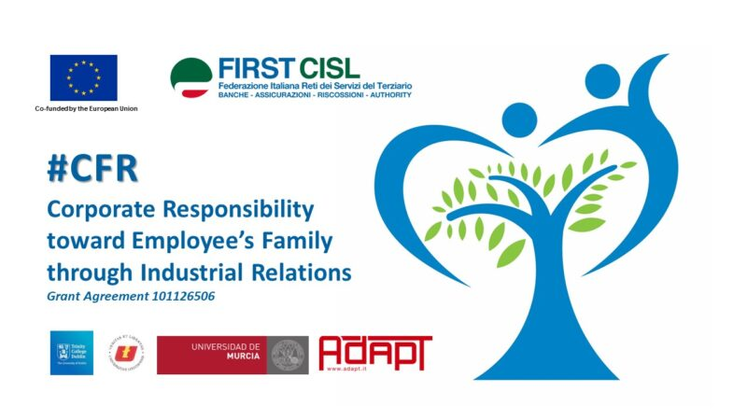
Corporate Family Responsibility, at the center of the new European First Cisl project
The new First Cisl project financed by the European Union "Corporate Responsibility toward Empoyee's Family through Industrial Relations" kicked-off in Siena last 23rd October 2023.
The aim of the 2 year project not only is to focus the company's attention and the development of Industrial Relations on the needs of workers, but also on those of their families, considered at the center of the complex network of relationships that contributes to forming the economic and social system as a whole.
First Cisl initiative is perfectly in line with the renewed objective of the European Commission to fully implement the pillar of social rights and is inspired, among others, by the Proposal for a Joint Report on Employment 2022, which suggests several points for reflection on the report between work and family responsibilities.
The main and innovative objective is to build a model for Industrial Relations in the financial sector aimed at implementing Corporate Family Responsibility policies. There is evidence that the adoption of CFR strategies improves the corporate climate and the satisfaction of workers and increases the productivity and profitability of companies.
The project makes use of the qualified collaboration of scientific partners: Adapt study centre, the University of Łodz, the University of Murcia and the Business school of Trinity College Dublin.
The transnationality of the project is also guaranteed by the involvement of Trade Union partners from 14 European countries (Italy, Denmark, Sweden, Finland, Greece, Bulgaria, Spain, Malta, Norway, Iceland, France, Romania, Hungary and Belgium) selected on the basis of experiences in the field of CFR.
Last, but significant is the partnership of the finance Trade Union Basisen from the candidate country Turkey.

