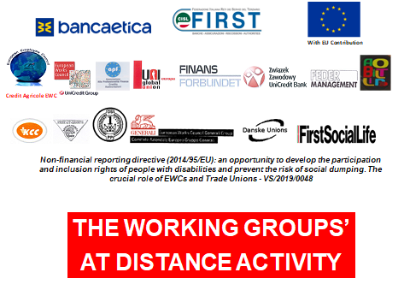

SWOT ANALYSIS

Evaluate critically the laws, collective agreements and good practices you have collected. Highlight the innovative and positive aspects and the opportunities but also the weaknesses and threats of each document using the SWOT analysis methodology. Please return the present questionnaire within the 15TH of October 2019.
Thank you!

NAME Linda Fauerholm……………………….
ORGANIZATION/TRADE UNION Financial Services Union………
COMPANY The union……………
COUNTRY Denmark………………….

SWOT ANALYSIS – DOCUMENT N.1 social chapter
TYPE OF DOCUMENT (collective agreement/law/good practice) ………………..
COMPANY/COUNTRY ………Denmark………………………………………….. DATE…………………

Point out and summarize the document’s strengths (positive and innovative aspects - steps forward with respect to the previous situation) and weaknesses (negative aspects and improvement areas), the opportunities (the possible positive future developments) and threats (external/internal factors that could put in danger the situation in the future).

Strengths
Weaknesses

- a part of the collective agreement……………………
- it states that the sector (also) is responsible for creating an inclusive labor market …………………………
- …………………………
- …………………………
- …………………………
- …………………………

- Nobody uses it and nobody keep an eye………………………
- it is very soft formulatet…………………………
- There are no penalties if the employer does not retain already employees
- …………………………
- …………………………

Opportunities
Threats

- …………………………
- …………………………
- …………………………
- …………………………
- …………………………
- …………………………

- it would been very nice if we could make the social chapter must more binding for the sector and the local employers……………
- …………………………
- …………………………
- …………………………
- …………………………
- …………………………

SWOT ANALYSIS – DOCUMENT N.2 Disability Discrimination Act

TYPE OF DOCUMENT (collective agreement/law/good practice) ………………..
COMPANY/COUNTRY Denamrk………………………………………………….. DATE 08/06/2018…………………

Point out and summarize the document’s strengths (positive and innovative aspects - steps forward with respect to the past situation) and weaknesses (negative aspects and improvement areas), the opportunities (the possible positive future developments) and threats (external/internal factors that could put in danger the situation in the future).

Strengths
Weaknesses

- it is an act…………………………
- It says all the right stuff
- it has different type of tools to keep and recruit people with disabilities on the labor marked …………………………
- …………………………
- …………………………
- …………………………
- …………………………

- nobody knows about it and the possibilities of the law and neither do the employers…………………………
- hiring people with disabilities should be difficult to avoid (ESG, CSR sustainability code o.a) …………………………
- …………………………
- …………………………
- …………………………
- …………………………

Opportunities
Threats

- …………………………
- …………………………
- …………………………
- …………………………
- …………………………
- …………………………

- …………………………
- …………………………
- …………………………
- …………………………
- …………………………
- …………………………

SWOT ANALYSIS – DOCUMENT N.3 (NAME/TITLE)

TYPE OF DOCUMENT (collective agreement/law/good practice) ………………..
COMPANY/COUNTRY ………………………………………………….. DATE…………………

Point out and summarize the document’s strengths (positive and innovative aspects - steps forward with respect to the past situation) and weaknesses (negative aspects and improvement areas), the opportunities (the possible positive future developments) and threats (external/internal factors that could put in danger the situation in the future).

Strengths
Weaknesses

- …………………………
- …………………………
- …………………………
- …………………………
- …………………………
- …………………………

- …………………………
- …………………………
- …………………………
- …………………………
- …………………………
- …………………………

Opportunities
Threats

- …………………………
- …………………………
- …………………………
- …………………………
- …………………………
- …………………………

- …………………………
- …………………………
- …………………………
- …………………………
- …………………………
- …………………………

SWOT ANALYSIS – DOCUMENT N.4 (NAME/TITLE)

TYPE OF DOCUMENT (collective agreement/law/good practice) ………………..
COMPANY/COUNTRY ………………………………………………….. DATE…………………

Point out and summarize the document’s strengths (positive and innovative aspects - steps forward with respect to the past situation) and weaknesses (negative aspects and improvement areas), the opportunities (the possible positive future developments) and threats (external/internal factors that could put in danger the situation in the future).

Strengths
Weaknesses

- …………………………
- …………………………
- …………………………
- …………………………
- …………………………
- …………………………

- …………………………
- …………………………
- …………………………
- …………………………
- …………………………
- …………………………

Opportunities
Threats

- …………………………
- …………………………
- …………………………
- …………………………
- …………………………
- …………………………

- …………………………
- …………………………
- …………………………
- …………………………
- …………………………
- …………………………

